Ladji Bamba | Justine Franklin | Rose Joshan | Omar King | David Spisak

AEDE 6120 | Ohio State

Auto Prepayment Risk Modeling

**Background**

According to Forbes, in the early 2000’s the outstanding debt of auto loans was over $1.307 billion in The United States. Some lenders engaged in “predatory” lending practices that encouraged borrowers to refinance their loans on terms that were not favorable to them. In January 2001, after several federally insured financial institutions experienced severe losses on subprime loan portfolios, The Federal Reserve, The Office of the Comptroller of the Currency, The Federal Deposit Insurance Corporation, and the Office of Thrift Supervision jointly issued guidelines requiring stricter supervision of banks that dealt in subprime lending.

During the early 2000s lenders started re-evaluating their risks held in loans, in case their borrowers defaulted on payment. Default is only one of the risks that lenders face. Lenders also face risk when their clients prepay on loans. This takes away interest earnings the lender was expecting over the length of the loan. It was during this time that banks and lending institutions started realizing they had to look at their lending practices and reevaluate their risk. They did this by reassessing interest rates, fees or penalties, and trying to find what is driving consumer behavior. This paper will focus on the prepayment, what the key variables are for prepayment, and what ways this can be predicted and modeled.

In 2017 the average auto loan for a new car was $31,099 and the average loan for a used car was $21,375. CNN Business estimates that 44% of Americans are relying on an auto loan to finance the purchase of their vehicle. With an industry this size there is plenty of opportunity for lenders to profit, but for lenders to secure profits they need a way to secure their investments. The financing industry has turned to forecasting and predictive analytics to help them make better informed business decisions based on known behaviors. Until 2015 almost all lenders and banks used the same economic models to predict loan payments and behavior of the economy. Considering the volatility of the market since the start of the great recession in the early 2000’s, lending agencies have been looking to create new models to more accurately predict the behavior of borrowers and behavior of the economy.

Huntington National Bank, headquartered in Columbus, Ohio is a regional Midwest bank located in 8 states. D&B Hoover’s Database projected as of December 31, 2018 Huntington Bank has a net worth of $109 Billion. DB Hoover also states that auto loans make up roughly 10% of Huntington’s business ($10.9 Billion). Huntington’s business model focuses on organic growth and reducing exposure to market volatility. It is important for Huntington’s risk management team to properly model and predict risk, one of those risks being borrower prepayment.

**Project description and motivation**

The goal of this analysis is to find economic indicators and portfolio characteristics that will predict prepayment behavior in Huntington’s indirect auto loan business segment. Often,

Risk management teams at banks and lending institutions rely on information similar to what will be mentioned in this report to accurately predict prepayment of loans. This paper will review the steps we took in completing this assessment.

To study prepayment behavior, Huntington provided 300 economic variables sourced from Moody’s Analytics. As a group we utilized economic intuition to narrow down the list to six variables. The Portfolio level data were obtained from Huntington National Bank. This data is includes portfolios cohorts such as Months on Book (MOB), FICO credit score, and Loan-to-value (LTV). Huntington collected macroeconomic variables from Moody’s Analytics and the Federal Reserve. The data included in this ranges January 2003 to March 2018. Our sample also includes two unique sets of forecast values for the macroeconomic variables for the periods April 2018 to March 2021. The unique sets are labeled Scenarios 1 and 2. Scenario 1 is considered basic economic conditions and scenario 2 is considered adverse economic conditions. The two scenarios are stress tests mandated by the federal government to ensure that banks hold enough cash reserve to withstand economic downturn.

One important thing to note is that the data provided contains periods of unique shocks in the economy including the Great Recession. We realize that this might have biased some of the variables, specifically the Housing Price Index (HPI). However considering the history of consumers utilizing funds from the refinancing of their home to prepay auto loans, we felt justified in control for changes in the housing market. The dates of our sample also include the period of Quantitative Easing from 2007 to 2017, where the Federal Reserve kept interest rates artificially low for a longer than usual during the economic recovery.

We utilize our selected variables to better understand how they affect portfolio measures like MOB (Month on Book) and FICO Cohorts. We felt that the age of the loan, the consumers’ confidence in the economy, as well as the consumers FICO score are all critical factors in determining whether or not a consumer will prepay on their auto loans. The age of the loan is measured by the proxy MOB. The lower the MOB the younger/newer the loan. Focusing on the age of the loan we consider looking at the vehicles in the portfolio that have the lower MOB’s as they are of greater interest to the lender as they have the greatest potential for gain from loan interest. With our teams’ intuition and advice from Huntington Risk Management team we decided to exclude the oldest MOB (MOB > 49 months) cohort. The logic is that these represent a small segment of Huntington’s portfolio and are thus lesser concern.

**Variables Selection Methods & Hypothesis**

To identify the independent variables that would best predict the prepayment risk, the large pool of available macroeconomic variables were classified into three buckets: financial factors, economic factors, and housing market factors. Using economic intuition and rationale we handpicked a subset of six predictor variables for our models, which will be referred to as the “Big Six” across this report. For modeling new and used auto prepayment, the Big Six were a standard across our three types of models, with the portfolio level data (MOB, FICO, LTV) used as controls. Lags of 3, 6, and 9 months are included, as we expect consumers take time to adjust their behavior to changes in the economy.

The Big Six include the following variables: Consumer Confidence, Treasury Bond 5 Year, Credit Card Charge Off, Net Cash Flow, Light Vehicle Sales, and the FHFA All Transaction House Price Index (HPI). Credit Card Charge Off and Net Cash Flows belong to the financial factors bucket. Treasury Bond 5 Year, Consumer Confidence, and Light Vehicle Sales belong to economic factors. Lastly, the FHFA HPI is our housing market factor. The majority of our variables fall under the economic factor bucket. We believe consumer sensitivity to varying conditions in the economy is a critical factor to predicting prepayment risk. In addition, the consumer's ability to finance loans is also a leading indicator.

Consumer Confidence is a fairly straightforward variable. The Consumer Confidence Index details consumer attitudes and buying intentions, capturing the effects of variables such as the unemployment rate. It gives an aggregated look at how consumers perceive the state of the economy and their ability to purchase goods and services. Consumer Confidence is a forward looking variable, so lagged effects would not be unexpected. Prepayment is expected to increase with a rise in consumer confidence.

Light Vehicle Sales is our next economic factor. It is a measurement of the number of cars and light trucks sold in the United States. An increase in the number of light vehicles being sold is expected to have a direct correlation with an increase in prepayments. A large portion of this would likely be the trade-ins of old vehicles. This variable also acts as a measurement for the state of the economy, with a high number indicating a healthy economy. Light Vehicle Sales is expected to have a positive relationship with prepayment.

Treasury Bond 5 Year shows current interest rates, also affecting individuals’ ability to purchase goods with credit. Higher interest rates would lessen the appeal of prepayment, as the loan for a newly bought car would likely have a higher interest rate than the old one. With this in mind, we expect to see a negative correlation between the Treasury Bond and prepayments. However, our results will show an overwhelmingly positive trend. It should be noted that interest rates only increase when the economy is doing well. In this way the Treasury Bond can serve as a proxy for the state of the economy, and would have a positive relationship with prepayment.

Credit Card Charge Off indicates that an account is delinquent and the credit card company is viewing it as a business loss. This occurs if an individual has not been making the minimum payments for more than 180 days. Not only is this an indication that an individual is not fiscally responsible and unlikely to be able to pay more than is due on their monthly loan, but a charge-off will also drop their credit score. This means that they are unlikely to be eligible for a loan to finance a new car. Credit Card Charge Off is expected to have a strong negative effect on prepayment.

Net Cash Flows measures the cash flow between businesses, or the difference between a company's cash inflows and outflows in a given period. It is an indicator of both the corporate economy and the national economy, with an increase in cash flow indicating the United States is doing well economically. In addition, there is expected to be a lagged effect where an increase in the cash flows within businesses can manifest in an increase in cash for consumers. This could be in salary raises or yearly bonuses. An increase in Net Cash Flows is thusly expected to result in an increase in prepayments.

Lastly, the FHFA All Transactions HPI is a measure of the movement of single-family house prices, including the sale, re-sale, and refinancing of homes. An increase in the FHFA HPI indicates that the economy is doing well and that consumers feel confident enough to be making big purchases. According to the Bureau of Economic Analysis, the real estate/housing industry were the leading contributor to the increase in U.S. economic growth in 2018. Consumers could be feeling confident enough in their financial situations to want to preemptively payoff their auto loan or trade in an old car for a newer one. However, as stated in the project description, we believe our results of the FHFA HPI may be biased by our data set, which will be reflected in our results.

The combination of these economic factors gives an insight into prepayment behavior from several aspects of the economy. In combination with the Big Six, the effects of FICO scores and MOB. An individual's FICO score indicating his credit history and MOB as a proxy for the age of the loan, are expected to also have effects on prepayment. In the later sections, we will see how the models based on MOB and FICO*MOB cohorts help to get a closer look at the key factors that affect prepayment behavior in both new and used auto loans.

**Exploratory Analysis**

Before we proceed to model selection methods, we performed preliminary tests of seasonality and stationarity on our dependent variable Prepayment Rate Annualized for both new and used auto segments. Proc X11 results in Table A1 show presence of seasonality in prepayments. Figure B1 shows that if seasonality is adjusted, there is less peak and trough in prepayments. To control for seasonality, we included monthly dummy variables in our models. We found that the March -October months were significant to prepayment rates which coincides to the same time when overall demand for cars increases. This provides evidence for the hypothesis that increased vehicle sales leads to more prepayment by way of trade-in market.

In a time series, we also expect data to be non-stationary. However, in this case our dependent variable is in a percent form, thus we expect series to be stationary. Accurate forecasting depends on the presence stationarity, meaning the mean and variance remain constant over time. To confirm our belief, we use the Augmented Dickey-fuller (ADF) test of stationarity. Results in Table A2 show that there is evidence of stationarity up to lag 7. However, for larger lags we cannot reject the null of non-stationarity. We understand that it is likely because the data set is small, thus our test loses power as lags increase. A later test of ADF on residuals helped us substantiate that at least our dependent and independent variables are cointegrated and data transformation such as first-differencing would not be required.

As we developed our final model, we performed statistical tests to check for normality, autocorrelation and heteroskedasticity. The Jarque-Bera test of normality results, as shown in Table A4, gives no evidence against the null of normally distributed residuals. The graph also shows that residuals are close to a normal distribution. To check for presence of any serial correlation in the error term, we opted for Breusch-Godfrey autocorrelation test. From the results in Table A5, we have clear evidence of autocorrelated errors. Thus, we use Newey-West robust standard errors to correct for autocorrelation. The Arch test of heteroskedasticity in Table A6 gives evidence of volatility clustering present in our data. Using Newey-West standard errors helps to correct for heteroskedasticity as well.

**Models Specification**

To analyze prepayment risk we constructed three models for new and used auto segments: Baseline model, MOB Cohort model, and Granular FICO by MOB model. The baseline model is comprised of monthly dummies, the Big Six and their lags, and controls for balance-weighted MOB, FICO and LTV. MOB, i.e. month on books, considered a proxy for the age of the loan.

Our MOB cohort model is further classified into 4 sub-models:

MOB < 12 months

13 <= MOB <= 24

25 <= MOB <= 36

37 <= MOB <= 48

In discussions with Huntington, we decided to not include data for MOB > 49. Rationale behind this exclusion is that longer the loan is on the books, less it adds value on the total portfolio. Banks like to focus on loans that are relatively younger. MOB model included additional controls for cohort specific balance-weighted FICO by MOB and LTV by MOB. The four MOB sub-models help to gauge the effect of economic variables, average FICO score and LTV on the prepayments on new versus old loans.

Granular model is also sub-divided into 16 models - an interaction between four FICO cohorts and four MOB cohorts. The granular models help to capture a more precise effect of economic indicators for each FICO category and under specific age of the loan. The purpose of having three types of models is to gauge the effect of each respective cohort on the prepayments in new and used auto loans.

**Model Selection Method**

We applied a stepwise selection procedure with selection entry and exit criteria of p-value < 0.1 to our pool of final controls and lags. We also used a variance inflation factor threshold, VIF <10, to avoid any multicollinearity issues among our variables.

For the Baseline and MOB model, the final estimation equation is:

https://lh6.googleusercontent.com/oJ7_wSH8BdYrnZ95IMLzk4bvoCiEdsmWdDGCFz5Jq-cbuVnNsmJkevtMC-FBLnwIPwPaauFZd3sqowC4-c2zldcHySvKzmv7IYytyphP2wIJmwiYFAm4CdM1HUWSy_4HcyoXMJIc758

Months is a vector of monthly dummies included in the model. Portfolio is the vector of balance-weighted MOB/ FICO/ LTV. Economic variable is a vector of the Big Six and their lags.

For the granular model, the final estimation equation is:



**Backtesting Baseline Model**

Before we draw forecasts from our models, we checked for how well our final models predict. Thus we perform an out-of-sample testing for the period from January 2017 to March 2018 and we train our model on the remaining period available, i.e. from January 2003 to December 2016. Results for both new and used auto are shown in Figure B3 and B4 below. Graphs give evidence that model predictions are in line with the actual data. For new auto forecasts, there is slight evidence of under prediction of prepayments for Q4 of 2017 and Q1 of 2018. For used auto, predictions are very close to the actual data. Overall, the results help us confirm that our models predict well.

**Figure B3**

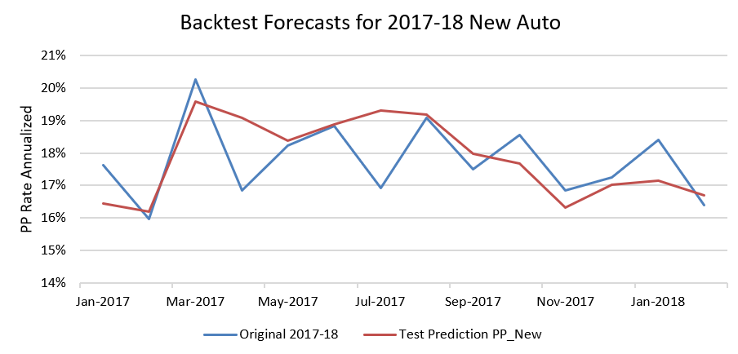

**Figure B4**

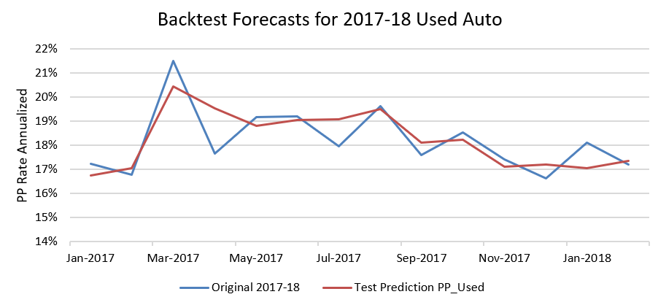

**Forecasts**

The forecasts for final Baseline model are shown in Figure B5 and B6. We model forecasts for two scenarios - Scenario 1 which is a base scenario and Scenario 2 which represents an adverse case. The forecasts for independent variables were provided by Huntington and balance-weighted MOB/ FICO/ LTV were held constant at their March 2018 values to get the forecasts.

The performance of the model can be evaluated from visual inspection in the graphs below. The predictions for both the scenarios are closely mirroring the actual prepayment data. In the initial forecast period of one-year, prepayments are projected to be very close in both the scenarios for new and used auto. This is likely due to two reasons. Firstly, the forecast values for independent variables are very close to each other for this period, which gives less room for any distinction in the prepayment forecasts. Secondly, the explanatory variables are lagged. Thus a significant change in the customer behavior would not be felt immediately, instead, it will take time to manifest.

In the rest of the forecast period for new auto, Scenario 1 projects the average prepayment close to 18% similar to that of actual data. While in case of Scenario 2, the prepayments are predicted to fall to an average of 14%. It is worth noting that there is not much gap between the projections from two scenarios. This indicates that new auto market is less sensitive to shocks in the economy.

For used auto market, the Scenario 2 predicts a relatively lower prepayment in the year 2020, but seems to converge to the prepayment projections of Scenario 1 by the year 2021. The gap between projections from two scenarios also show less sensitivity to economic shocks, however convergence in the later period also indicates that prepayments do not change much in conditions when economy is doing well versus when there are shocks in the economy.

**Figure B5**

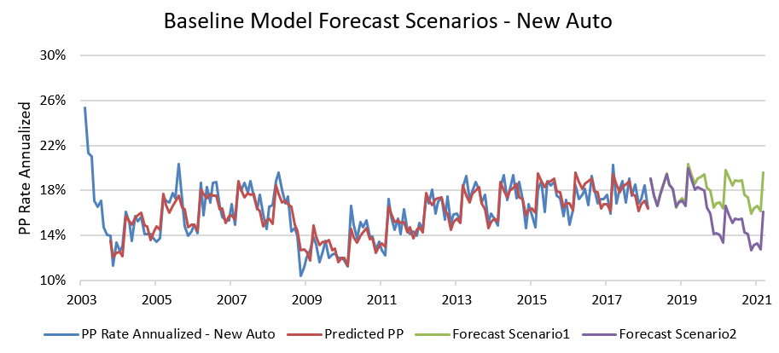

**Figure B6**

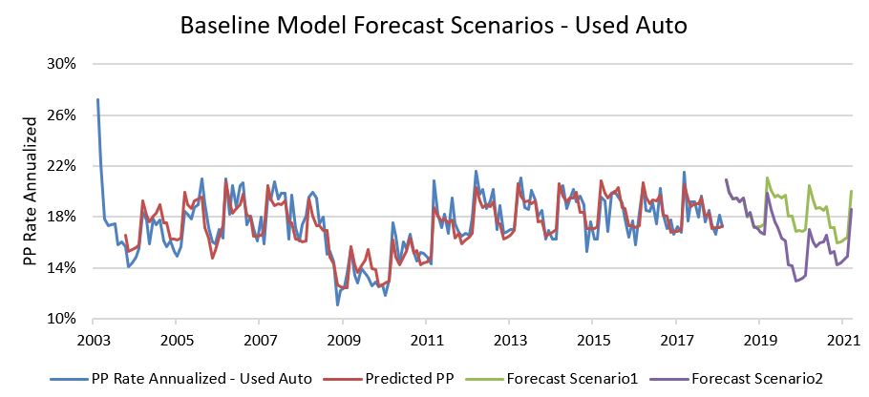

**Forecast Sensitivity Analysis - Baseline Model**

It is important to identify which of the variables in our baseline model drives the prepayments the most. We ran a sensitivity check on both the baseline models i.e. for new and used auto. In this process, we pick one variable at a time and replace the values in Scenario 1 with the values from Scenario 2 and vice versa. New forecasts on the resulting data are drawn each time this step is performed. From the forecasts for each individual variables, we capture mean absolute percent deviation (MAPD) statistics. This helps us to check the percent deviation of new forecasts from the actual forecasts due to changes in the respective variable.

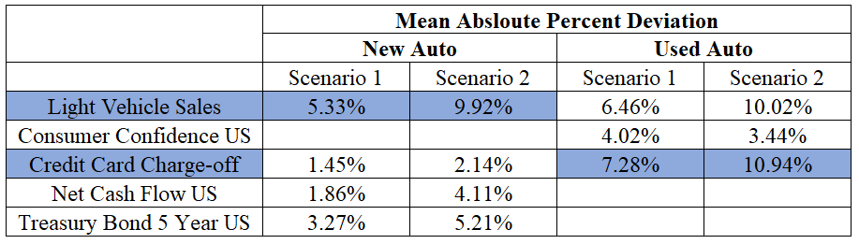

Results in the table above show that light vehicle sales is the leading driver of prepayments in new auto loans. It has a larger effect in Scenario 2, which indicates that if the economy is in adverse conditions and the light vehicles is kept at baseline economy level then prepayments change by almost 10%. Likewise, credit-card charge-off is the most important driver of prepayments in used auto loans and changes prepayments by upto 7% in Scenario 1. Again we see a large effect happening in Scenario 2 where all other variables are held constant at their adverse economy levels while Credit Card Charge Off is at its baseline economy levels.

**Regression Results and Interpretation**

**Baseline Model - New Auto**

Table A7 given in the appendix shows the outcome of stepwise selection process. Consumer Confidence (CCI), FHFA All Transactions HPI (HPI), Light Vehicle Sales (LVS) and Credit Card Charge Off (CCC) makes the set of four variables that explain the variation in prepayments for new auto. As we expected, the LVS show a positive correlation with prepayments on new cars. Because as people buy more light vehicles, they trade-in more on their current vehicle which tends to drive prepayments almost immediately. Similarly, CCC show a negative correlation with prepayments on new cars. It implies that if customers are not paying debts on their credit-cards, they are also less likely to prepay on their auto loans. HPI shows a positive association with prepayments, thus indicating prepayments in new auto loans will drive up, with an increase in house prices. CCI, on the other hand, shows an unexpected negative correlation with prepayment. It might be likely that during good times, customers who afford to buy new cars prefer to make other investments than paying off the loan on their car.

**Baseline Model - Used Auto**

Table A8 given in the appendix shows the outcome of stepwise selection process. Consumer Confidence (CCI), Light Vehicle Sales (LVS) and Credit Card Charge Off (CCC) are the three variables that explain variation in used auto prepayment risk. Credit Card Charge Off is the variable with the greatest magnitude. An increase in CCC yields a 0.5% decrease in prepayment rate. This results is in line with our hypothesis that increased credit card delinquency in the economy will lead to lower prepayment rates. Also important to note that LVS included both the third and ninth lags of this variable. As a result we included a differenced coefficient to capture the effect of both lags on prepayment risk. The third lags is positive while the ninth is negative. We interpret this to mean three months after an increase in LVS prepayment increase and then subsides in the ninth after the spike in LVS. The differenced LVS is positively correlated with used auto prepayment rates. LVS is in line with our aforementioned trade-in hypothesis. CCC corresponds with consumer positive outlook on the overall economy and is confirmed to positively increase prepayment on used vehicles.

**MOB COHORTS**

We divided Months on Book into four cohorts: MOB <= 12, 13 <= MOB <= 24,

25 <= MOB <= 36, and 37 <= MOB <= 48. Accordingly, MOB <= 12 is the youngest loans, and 37 <= MOB <= 48 the oldest. This analysis will check if variables behave differently depending on the age of the loan. New and used auto prepayment will also be differentiated. We can observe which variables affect prepayment behavior differently depending on if the car is new or used, since both can have different drivers. Before our analysis, we assume that, if a person has low MOB, it is likely that customers are not thinking about pre-payments. One scenario can be that customers wanted to intentionally pay for the car, but because they had a good deal with the loan they took the loan.

**New Auto**

MOB <= 12 for new auto contains the variables + FHFA HPI with a 3rd lag, + Light Vehicle Sales with a 3rd lag, and – Credit Card Charge off with a 9th lag. The variables within this cohort all have the expected relationships with prepayment. There are not many variables within the cohort, which is expected as newly purchased cars, indicated by the age of the loan, are less likely to be traded in or completely paid off.

13 <= MOB <= 24 contains the variables – FICO*MOB, + Net Cash Flow with a 9th lag, + Light Vehicle Sales, – Credit Card Charge Off, and – Treasury Bond 5 Year. With the exception of the FICO*MOB interaction term, the signs on the variables are as predicted. While an increase in an individual's FICO score would intuitively lead to an increase in prepayment, as it indicates an increase in fiscal responsibility and the ability to pay off loans, there is a logical explanation behind why this is not the case for this particular cohort. The loans are still relatively young for these cars, with the cars themselves also being relatively young. Additional monthly payment on a loan is not likely to result in a payoff of the loan at this point, making prepayment less alluring. The car itself is only between 1 and 2 years old, making trade-ins less likely. With this in mind, the negative sign on FICO*MOB can indicate that while an individual’s FICO score is increasing, they are focusing on paying other loans or purchasing other goods.

25 <= MOB <= 36 contains the variables – FHFA HPI with a 3rd lag, + Net Cash Flows with a 9th lag, + Light Vehicle Sales, – Credit Card Charge Off, and + Treasury Bond 5 Year with a 9th lag. The variables act as expected except for Treasury Bond 5 Year and the FHFA HPI. Treasury Bond 5 Year is likely picking up on the effect of an improving economy, resulting in its positive sign. The negative correlation on the FHFA HPI is less obvious, though it is a trend that continues. We expect that this sign is a symptom of the data that we use, with the financial crisis in the middle of the 2003-2017 data set. This will be explored further in the granular model.

37 <= MOB <= 48 contains the variables + Consumer Confidence with a 9th lag, – FHFA HPI with a 9th lag, + Net Cash Flow with a 9th lag, and + Light Vehicle Sales with a 3rd lag. The variables act as expected with the exception of the FHFA HPI, with the previous explanation still in effect. We expect findings within this cohort to be less relevant on the whole, as these loans are older and likely to be paid off relatively soon.

**Used Auto**

In the MOB <= 12 cohort,the main drivers of used auto loans’ prepayment are consumer confidence and credit card charge off with statistical significance at 1% level. Assuming that consumers with low MOB usually do not intend to prepay their auto-loans, credit cards charge off will, even more, sustain that intention to not prepay, especially for used cars. They will consider them paying off only if they are confident about the economy.

In this the 13 <= MOB <= 24cohortresults show that consumers with High FICO score are more likely to prepay as they show more financial responsibility. Net cash flows and Treasury bond 5 years capturing the aspect of a good economy, could stimulate consumers to prepay their loans. Only surprising result was the negative correlation of consumer confidence with prepayments. We interpret it as a consequence of the lag nature of the variable itself, since it mainly depends on consumers’ feelings, therefore very sensitive.

In the third cohort, 25 <= MOB <= 36**,** Treasury bond 5 years and high FICO score drive positively consumers behavior toward prepayments. However, FHFA All Transaction HPI seems to discourageprepayments, which is not intuitive. We suspect that the housing crisis may have influenced this variable.

Lastly, the final cohort 37 <= MOB <= 48shows again how consumers rely on treasury bonds 5 years, credit card charges off and consumer confidence before prepaying their used auto loans. As this results are statistically significant, we think that consumers would have less intention to pay off their loan the older it gets.

**GRANULAR MODELS**

The granular models interact each level of FICO scores by each level of MOB, resulting in 16 FICO*MOB cohorts. FICO scores are divided by FICO <= 725, 725 <= FICO <= 774, 744 <= FICO <= 815, and FICO >= 815. In ascending order FICO 1*MOB 1 represents consumers with the lowest FICO score and MOB less than 12 month (MOB <= 12).

Results are presented in the Appendix.

To succinctly analyze all sixteen of these cohorts, we look at trends in the behavior of each variable. Using this method it is possible to see if variables have different effects depending on FICO and MOB, or if they behave the same regardless of these factors. Similarly to the purely MOB cohorts, these results will also be divided into new and used auto, resulting in a total of 32 cohorts. Different approaches are taken between new and used auto to better capture consumers’ patterns.The first of these analyses will be new auto FICO*MOB.

|  |  |
| --- | --- |
| **Used Auto Loans** | **New Auto Loans** |
| **NET CASH FLOW (3/16)** | **CONSUMER CONFIDENCE** (5/16) |
| **CONSUMER CONFIDENCE 5/16** | **CREDIT CARD CHARGE OFF** (8/16) |
| **LIGHT VEHICLE SALES (7/16)** | **NET CASH FLOW** (8/16) |
| **FHFA ALL TRANSACTIONS HPI (9/16)** | **TREASURY BOND 5YR** (9/16) |
| **CREDIT CARD CHARGE OFF** (10/16) | **FHFA ALL TRANSACTIONS HPI** (9/16) |
| **TREASURY BOND 5YR (10/16)** | **LIGHT VEHICLE SALES** (9/16) |

**New Auto**

Consumer Confidence appears in 5 of the 16 cohorts. The effect of the variable is consistently positive and most often the 9th lag. This is consistent with our initial expectation of Consumer Confidence. It does not show a particularly consistent trend across FICO or MOB interaction cohorts.

Credit Card Charge Off appears in 8 of the 16 cohorts. The effect of the variable is consistently negative with a mix between the level and 9th lag. This indicates that an increase in Credit Card Charge Off decreases prepayment immediately and in the future. These findings are consistent with our expectations. Credit Card Charge Off is found in three of the four cohorts within FICO 2, or the second lowest FICO group. This implies that Credit Card Charge off may be especially important in determining if individuals are less likely to prepay on auto loans within 725 <= FICO <= 774.

Net Cash Flow appears in 8 of the 16 cohorts. It is consistently positive with a 9th lag, with the exception of the two lowest FICO groups with the two newest MOBs, where the effect is negative at the 3rd lag. The positive 9th lag is in line with what we expect to see, with an increase in Net Cash Flows eventually leading to increases in salary or bonuses further down the line. This increase in money for the consumers can lead to an increase in prepayment. While the positive 3rd lag is initially puzzling, a plausible hypothesis is that the increase in cash flow among some businesses may be due to layoffs. Assuming that those in lower FICO groups are generally financially worse off than those in higher, it could be postulated that those within these FICO groups are more likely to hold jobs that are likelier to lay off workers to cut costs. This would result in a decrease in prepayments.

Treasury Bond 5 Year appears in 9 of the 16 cohorts. The lag is inconsistent, although the effect is positive in all but FICO 4, the highest FICO group. This implies that most of the cohorts are picking up on the improving economy, resulting in a positive correlation with prepayment. Those with the highest FICO scores, and theoretically with the highest income, seem to be the only group that specifically responds to an increase in interest rates. This suggests that this group of individuals is the most sensitive to changes in interest rates and the likeliest to change their behavior accordingly.

FHFA All Transactions HPI appears 9 of the 16 cohorts. The of majority of this variable comes in the 9th lag, consistently negative except for MOB <= 12, the newest loans. As mentioned in the MOB cohorts, we believe the negative effect of FHFA HPI is a symptom of the dataset. The financial crisis was a result of the collapse of the housing market. 9 months after the last time the HPI increased before the housing crash, most individuals would not be thinking about getting new cars not have the money to prepay on current vehicles. As such, prepayment would go down. The exception to this is for newly purchased new auto. These would be vehicles with high payments that the consumer has fairly recently acquired, meaning they less used to giving up this amount of money than later MOB cohorts. This group could be trading in for cars with lower payment rates during this period, increasing prepayment.

Lastly, Light Vehicle Sales is consistently positive at the level. This is what we expected to observe. Consumers generally either turn in an old cars or finish paying off an old loan before purchasing a new vehicle. This variable shows up seven times between the lowest two FICO groups. This indicates that those in the lower income spectrum likely tend to trade in their cars before getting new ones, while those in the higher FICO groups may have multiple vehicles and are less likely to feel the need to turn in old cars before getting new ones. Those in higher income brackets are more likely to have multiple cars, adding credence to this.

**Used Auto**

In this section, we found consistencies by analyzing through MOB cohorts taking into consideration consumers’ FICO score. Within MOB <= 12credit card charge-off appears in 3 FICO cohort (1, 2, and 4). This implies that, regardless of a consumer FICO score, credit card charge-off reduces the likelihood to prepay auto loans that are less than 12 months.

In 13 <= MOB <= 24Treasury Bonds 5 yearsshows in the lower FICO cohorts (1 and 2), while FHFA_AllTrans_HPI_USshows in the Upper FICO cohorts (2, 3 and 4). At this stage of the loan, consumers from lower FICO cohorts are impacted by the indirect effect of the 5 years Treasury Bonds, while higher FICO score consumers are driven by the the FHFA HPI, which negative sign is probably capturing the housing crash.

In 25 <= MOB <= 36LT_VHL_SALES_USappears in almost all FICO cohorts (1,2 and 4). Thus, if a loan is between 25 and 36 months old, then regardless of the FICO score, an increase in Light vehicle Sales increases the likelihood of consumers to either prepay their auto loans or trade-in their car.

37 <= MOB <= 48shows no consistencyin estimators between FICO cohorts. This implies that, when loans get older, it becomes difficult to capture consumers’ prepayment behavior.

**Summary & Conclusions**

While there is not crystal ball to perfectly predict the future or the economy or the behavior of consumers, we feel that consumer confidence is a pretty good indicator of predicting auto loan prepayment. Also that credit card charge off, and Light Vehicles Sales (LTV) are strong economic variables in predicting prepayment of auto loans.

Higher the Credit Card Charge off rates the less likely consumers are to prepay on auto loans for both new and used vehicles. This hold true across all FICO Cohorts. This is as we predicted, and we feel that as consumers become more than 180 days delinquent in paying their credit card balances, it is an indication there could be trouble paying their bills.

An additional conclusion when looking at behaviors of consumers when paying off their auto loans for new vehicles, is that consumers of new vehicles loans are most likely to pay off their auto loan between 12- and 24 months. This seems to make sense as consumers who just purchase their vehicles don't want to pay off their loan just after purchase. And they might not want to keep that loan for the traditional 60 months. New vehicles are most often purchased by those in a slightly better financial situation.

When looking at the prepayment of used vehicles that time frame of prepayment is slightly delayed from those of new vehicles. Used vehicle loans are on average less than that of a new vehicle loan. Most persons who purchase a used vehicle might not be able to afford a new vehicle based of their financial situation. When looking at when the highest probability of used loans are paid off it between 24 and 36 months.

The correlations of the variables in our results were overall what we expected and from our results they can be justified. We feel fairly confident that our results do show some indications that prepayments are hard to predict, and there is a list of other things to consider when reviewing the results. There continues to be new developments in the auto industry such as autonomous vehicles, and different transportations options including rideshare apps and public transit which both would affect the sales of vehicles. With the sales of light automobiles affecting the number and amount of loans could be affected as well.

We are confident that as this analysis is performed on Huntington’s own portfolio data, RMA team will be able to structure its modeling approach based on the models and results presented here.

**References**

**·**A record 107 million Americans have auto loan debt. “A Record 107 Million Americans Have Car Loans.” *CNNMoney*, Cable News Network, [money.cnn.com/2017/05/19/news/economy/us-auto-loans-soaring/index.html](https://money.cnn.com/2017/05/19/news/economy/us-auto-loans-soaring/index.html).

Housing's Contribution to Gross Domestic Product (GDP).” NAHB, [www.nahb.org/en/research/housing-economics/housings-economic-impact/housings-contribution-to-gross-domestic-product-gdp.aspx.](http://www.nahb.org/en/research/housing-economics/housings-economic-impact/housings-contribution-to-gross-domestic-product-gdp.aspx.)

· *D&BHoovers Database*, [app.avention.com/company/ac26cebb-6f3c-32ae-8578-623b3a09c014#report/company_summary.](https://app.avention.com/company/ac26cebb-6f3c-32ae-8578-623b3a09c014#report/company_summary)

· McCarthy, Niall. “The Rise In U.S. Auto Loan Debt Shows No Signs Of Slowing Down [Infographic].” *Forbes*, Forbes Magazine, 3 Jan. 2019, [www.forbes.com/sites/niallmccarthy/2019/01/03/the-number-of-americans-holding-auto-loan-debt-shows-no-signs-of-slowing-down-infographic/#72b6b2737ffe.](http://www.forbes.com/sites/niallmccarthy/2019/01/03/the-number-of-americans-holding-auto-loan-debt-shows-no-signs-of-slowing-down-infographic/#72b6b2737ffe.)

· Morgan, Kyle, and USA Today. “Car Loan Statistics 2019 | Americans Owe $1.1 Trillion in Auto Debt.” *Finder US*, 22 Mar. 2019, [www.finder.com/car-loan-statistics.](http://www.finder.com/car-loan-statistics.)

· “Online Banking, Insurance and Investing | Huntington.” *Huntington, Welcome*, [www.huntington.com/](http://www.huntington.com/).

Howells, T. (2019). *Gross Domestic Product by Industry: First Quarter 2018*. [online] Bea.gov. Available at: https://www.bea.gov/system/files/2018-07/gdpind118_3.pdf .

We would also like the thank Andriy Shyshkov Senior Risk Modeling Manager at Huntington National Bank, Dr. Abdul Sam Professor at The Ohio State University, and Keterine Ramirez PhD Student at The Ohio State University for their help and guidance over this project and coursework.

**Appendix**

**Table A1**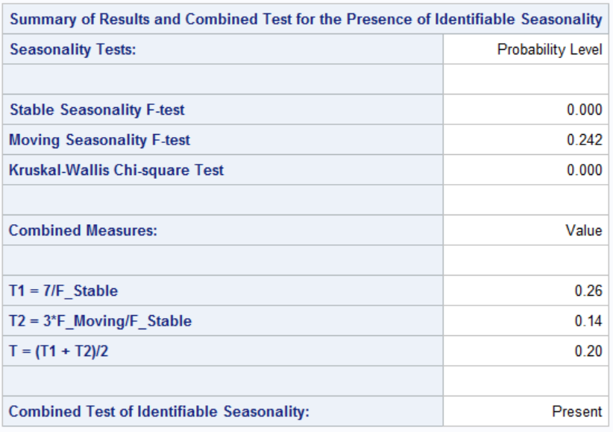

**Table A1-B**

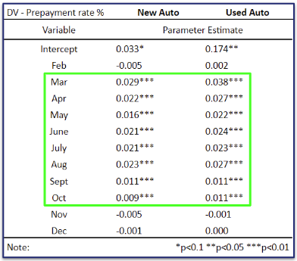

**Figure B1**

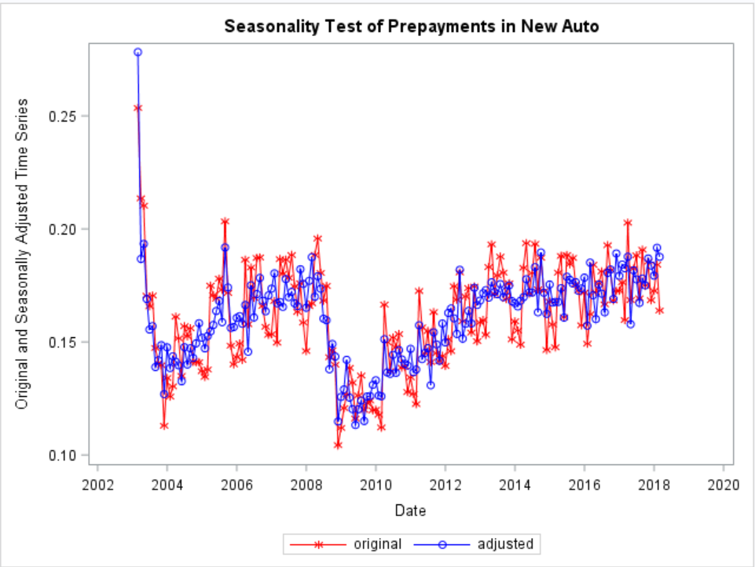

**Table A2 Table A3**

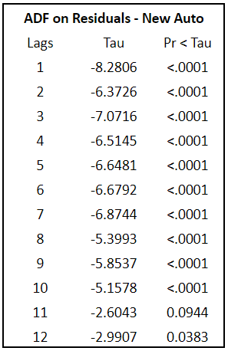

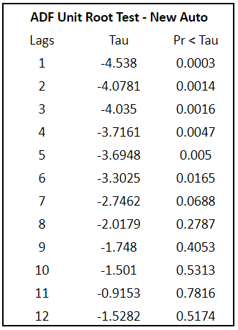

**Table A4**

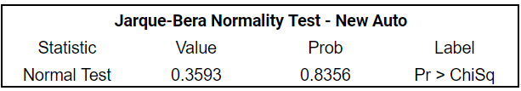

**Figure B2**

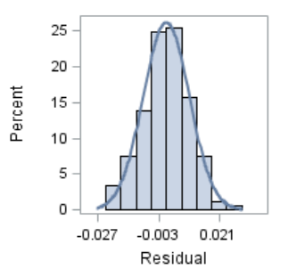

**Table A5 Table A6**

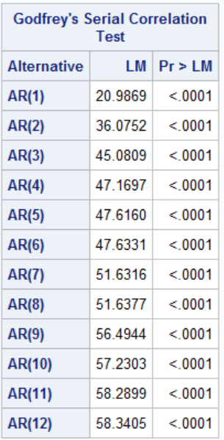 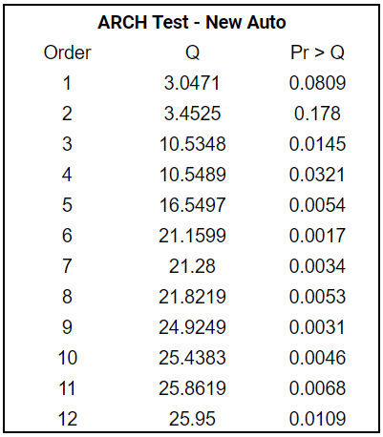

**Regression Result Tables**

***Table A7: Baseline Model - New Auto***

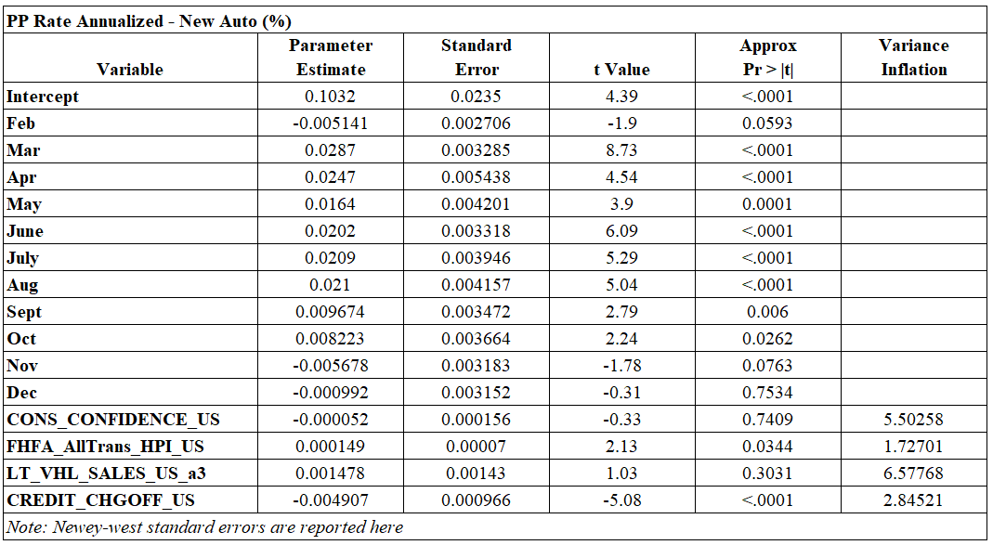

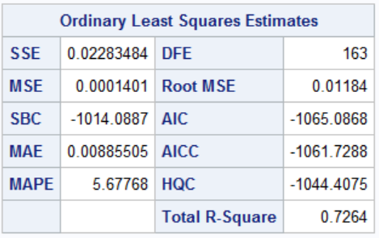

***Table A8: Baseline Model - Used Auto***

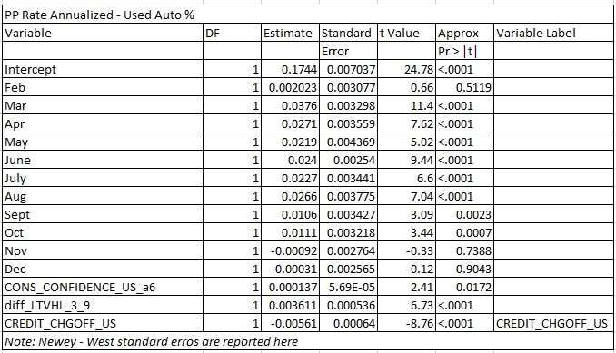

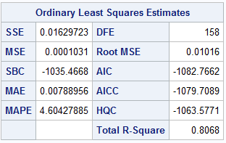

***New Auto Distribution***

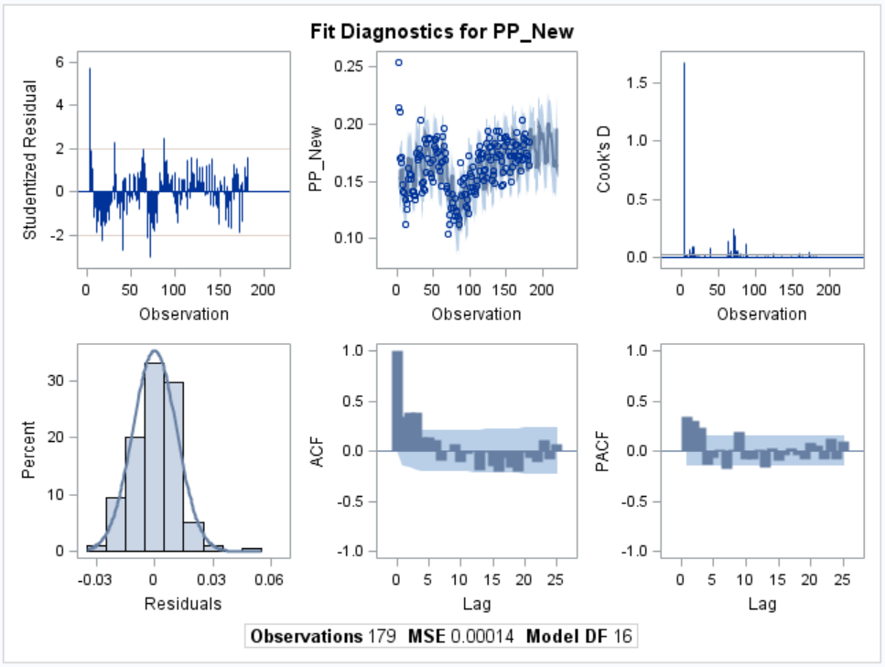

***Used Auto Distribution***

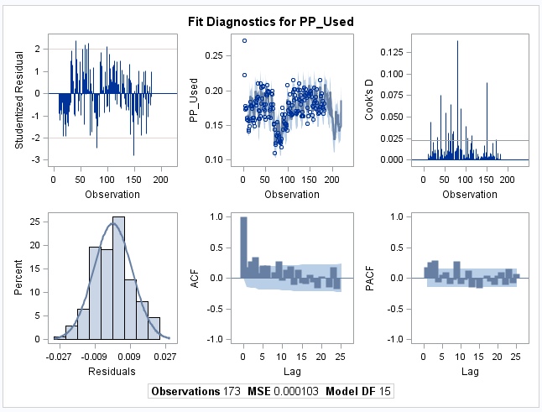

***MOB <= 12***

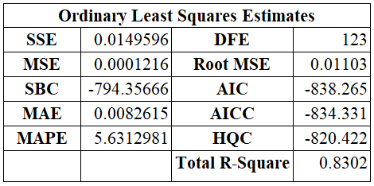

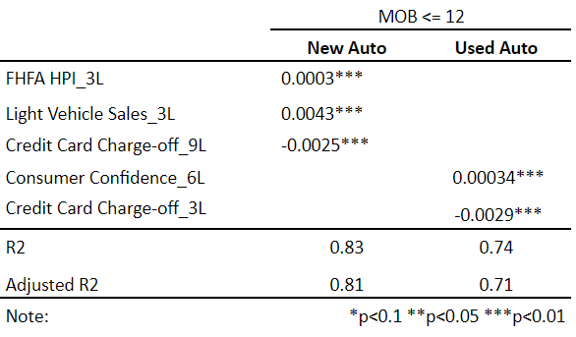

***13 <= MOB <=24***

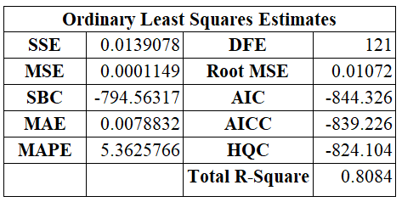

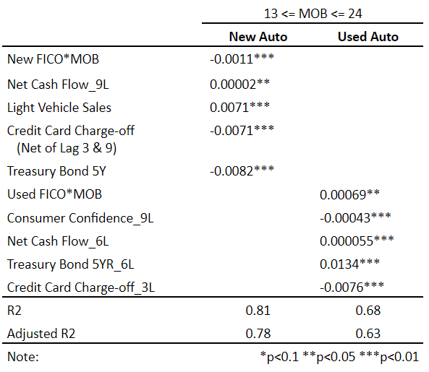

***25 <= MOB <= 36***

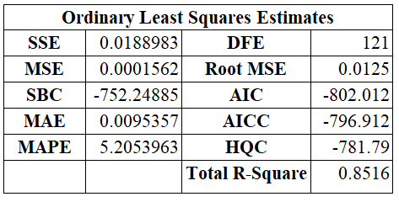

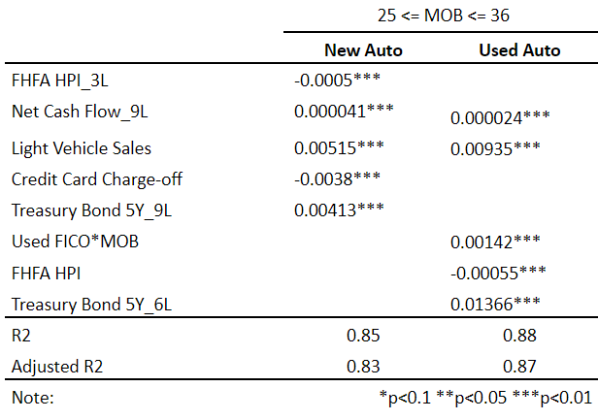

***37 <= MOB <=48***

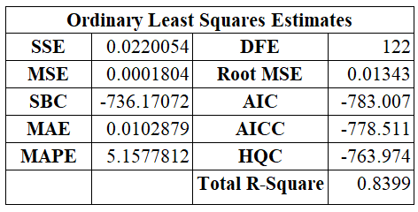

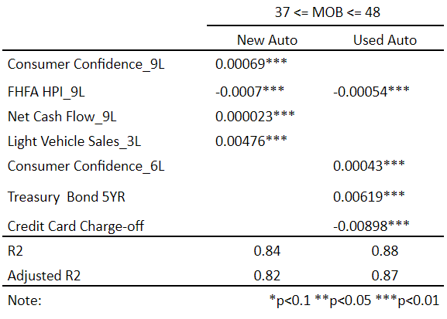

**Granular Model / NEW auto loans**

|  |  |  |  |  |
| --- | --- | --- | --- | --- |
|  | MOB 1 | MOB 2 | MOB 3 | MOB 4 |
| FICO 1 | **LT_VHL_SALES_US** | **LT_VHL_SALES_US** | **LT_VHL_SALES_US_a3** | **LT_VHL_SALES_US** |
|  |  | **NET_CASH_FLOW_US_a3** | **NET_CASH_FLOW_US_a9** | **NET_CASH_FLOW_US_a9** |
|  |  | **FHFA_AllTrans_HPI_US_a9** | **FHFA_AllTrans_HPI_US_a9** | **FHFA_AllTrans_HPI_US_a9** |
|  | **TBOND_5YR_US_a3** | **diff_credit1_9** | **TBOND_5YR_US_a9** | **TBOND_5YR_US_a6** |
|  | **CREDIT_CHGOFF_US** | **diff_tbond_1_6** |  | **CREDIT_CHGOFF_US** |
| FICO 2 | **TBOND_5YR_US_a6** | **FHFA_AllTrans_HPI_US_a3** | **FHFA_AllTrans_HPI_US_a9** | **FHFA_AllTrans_HPI_US_a9** |
|  | **LT_VHL_SALES_US** | **LT_VHL_SALES_US** | **LT_VHL_SALES_US_a3** |  |
|  | **CONS_CONFIDENCE_US_a6** | **CREDIT_CHGOFF_US** | **CREDIT_CHGOFF_US** | **CONS_CONFIDENCE_US_a9** |
|  | **NET_CASH_FLOW_US** | **CREDIT_CHGOFF_US_a9** | **CREDIT_CHGOFF_US_a9** | **CREDIT_CHGOFF_US** |
|  | **NET_CASH_FLOW_US_a3** |  |  |  |
| FICO 3 | **FHFA_AllTrans_HPI_US_a6** | **FHFA_AllTrans_HPI_US_a9** | **FHFA_AllTrans_HPI_US_a9** |  |
|  | **CREDIT_CHGOFF_US_a6** | **NET_CASH_FLOW_US_a9** | **NET_CASH_FLOW_US_a9** | **diff_credit1_6** |
|  |  | **TBOND_5YR_US_a9** | **CONS_CONFIDENCE_US_a9** | **TBOND_5YR_US_a3** |
| FICO 4 | **FHFA_AllTrans_HPI_US_a6** | **CONS_CONFIDENCE_US_a9** | **NET_CASH_FLOW_US_a9** | **CONS_CONFIDENCE_US** |
|  | **LT_VHL_SALES_US_a9** | **LT_VHL_SALES_US** |  |  |
|  | **CREDIT_CHGOFF_US_a9** | **CREDIT_CHGOFF_US_a9** |  |  |
|  | **TBOND_5YR_US_a3** |  | **TBOND_5YR_US_a3** | **TBOND_5YR_US_a6** |
|  | **TBOND_5YR_US_a9** |  |  |  |

**Granular Model / USED Auto loans**

|  |  |  |  |  |
| --- | --- | --- | --- | --- |
|  | MOB 1 | MOB 2 | MOB 3 | MOB 4 |
| FICO 1 | TBOND_5YR_US | TBOND_5YR_US_a9 | LT_VHL_SALES_US | TBOND_5YR_US |
|  | CREDIT_CHGOFF_US | NET_CASH_FLOW_US_a9 | FHFA_AllTrans_HPI_US_a6 | FHFA_AllTrans_HPI_US_a9 |
|  | diff_LTVHL_0_9 |  |  | LT_VHL_SALES_US_a3 |
|  |  |  |  |  |
| FICO 2 | CONS_CONFIDENCE_US_a3 | TBOND_5YR_US_a6 | TBOND_5YR_US_a6 | CONS_CONFIDENCE_US |
|  | NET_CASH_FLOW_US | LT_VHL_SALES_US | LT_VHL_SALES_US |  |
|  | CREDIT_CHGOFF_US_a3 | FHFA_AllTrans_HPI_US_a3 | FHFA_AllTrans_HPI_US |  |
|  |  |  | NET_CASH_FLOW_US_a9 |  |
|  |  |  |  |  |
| FICO 3 | CONS_CONFIDENCE_US | FHFA_AllTrans_HPI_US | FHFA_AllTrans_HPI_US_a9 | FHFA_AllTrans_HPI_US_a6 |
|  |  | CREDIT_CHGOFF_US_a6 |  | CREDIT_CHGOFF_US |
|  |  |  |  |  |
| FICO 4 | CREDIT_CHGOFF_US_a6 | CONS_CONFIDENCE_US_a9 | diff_CREDIT_CHGOFF_US_0_6 | CREDIT_CHGOFF_US |
|  | FHFA_AllTrans_HPI_US_a9 | FHFA_AllTrans_HPI_US_a9 | LT_VHL_SALES_US_a9 | LT_VHL_SALES_US_a9 |
|  | diff_TBOND_5YR_US_3_9 |  |  |  |